**PROBLEM 01**  
  
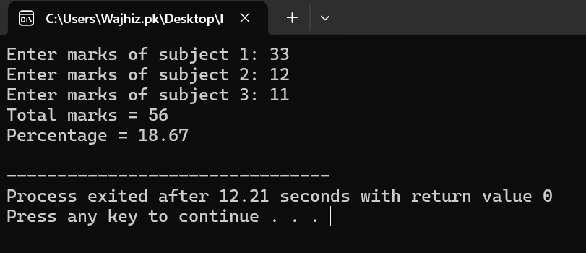  
  
  
  
  
  
  
  
  
  
**PROBLEM 02**  
  
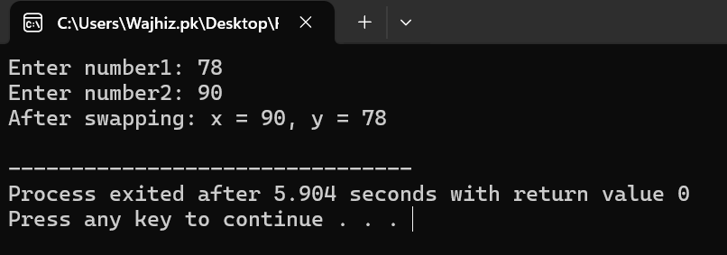  
  
  
  
  
  
**PROBLEM 03**  
  
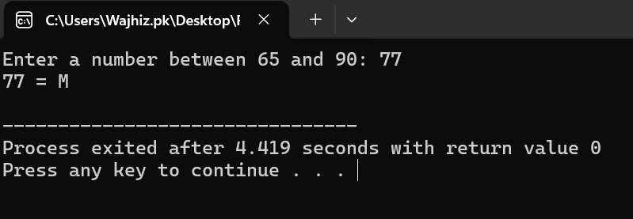  
  
  
  
  
  
  
  
  
**PROBLEM 04**  
  
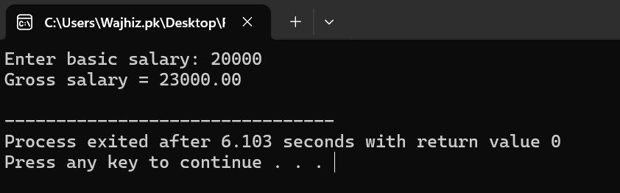  
  
  
  
  
  
**PROBLEM 05**   
  
  
  
